|  |  |
| --- | --- |
|  | Web Development Part 1 Proposal 1 |
|  |  |
|  | Retang Theledi Kekana  WEDE5020/p/w  8/22/25 |

Contents

**1.** **Organisation Overview.** 2

**2.** **Website Goals.** 2

**3.** **Target Audience.** 2

**4.** **Website Features.** 2

**5.** **Design Aesthetic.** 3

**6.** **Technical Stack.** 3

**7.** **The Timeline and Budget.** 3

References 5

# **Organisation Overview.**

Fansies is a made-up company that designs, creates and retail phone covers that are animated from popular cartoons. The company was founded on the year 2025 by a small group of students that were uninterested in modern phone covers, so they had decided to create a new unique style of covers. Fancies will offer more animated and lively designs that will be inspired by mainly cartoon characters. The business will target people from thirteen to adults who still hold value in the art of animation.

# **Website Goals.**

* Fansies aims to create a collection of creative and animated phone covers.
* The company also aims to allow permission for safe online shopping.
* Fansies also aims to create an identifying brand by telling stories through the phone covers.
* The company also plans to allow customers to engage with designers by reviewing their products and analysing their feedback.
* The company aims to use social media platforms to their advantage. (Gontarek, 2021).

# **Target Audience.**

* Fansies aim to reach a target audience from thirteen to thirties.
* Fansies are aiming to reach people who are interested in cartoons, anime, or gaming.
* The behaviour will be users that are frequently using their mobiles.

# **Website Features.**

* The Homepage will have different cartoon characters that will be applied to the phone covers.
* The website will have a gallery where products are filtered.
* The website will also include a query page where a customer can select a unique design from the existing catalogue.
* A contact page will be created that will have social media links. (Gontarek, 2021).
* The website will be receptive and reactive for mobile devices and desktops. (Curtis, 2024).

# **Design Aesthetic.**

Fansies’ website will use colourful palette of colours such as pink, blue, and purple. The website will also consist of “sans-serif” fonts and will include cartoon characters that will resemble Fancies image. The Wireframes will be made using tools such as Figma.

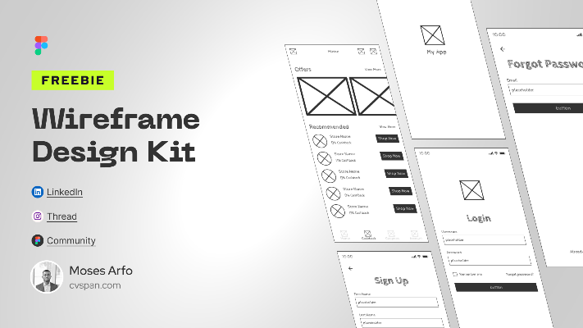

(Arfo, 2023)

# **Technical Stack.**

* The website will need to be developed on HTML5, CSS3 and JavaScript.
* GitHub must be installed for version control. (GitHub, 2024).
* The website will be hosting through a shared plan such as HostAfrica. (S., 2025)
* Fansies will get animation characters from Jitter or Freepik.

# **The Timeline and Budget.**

|  |  |  |
| --- | --- | --- |
| The Project Phase. | The Duration of the Project. | The Estimated Costs. |
| Making research and planning the project. | (1-2 Week) | R0 (As this research will be done online) |
| Design the project and the Wireframes. | (2-3 Week) | R 700 (for Jitter) (Arfo, 2023). |
| Developing the Project. | (3-4 Week) | R 2 000 |
| Hosting the project and Domain. | (4 Week) | R500 |
| Intangibles assets. | Continuous | R300 |
| Testing the project and releasing it. | (4-5 Week) | R0 |
| Total Amounts. | N/A | R3 500 |

# References

Arfo, M. (2023, Auguest 1). *Wireframe Design Kit*. Retrieved from figma.com: https://www.figma.com/community/file/1268740083933144270/wireframe-design-kit

Curtis, R. (2024, July 27). *Budgeting for a Website Project: A Comprehensive Guide*. Retrieved from www.alteredvisiondesigns.com: https://www.alteredvisiondesigns.com/website-design/budgeting-for-a-website-project/

GitHub. (2024, Juky 29). *What is Version Control?* Retrieved from github.com: https://github.com/resources/articles/software-development/what-is-version-control

Gontarek, M. (2021, September 13). *Top Reasons Why Your Startup Should Use Social Media*. Retrieved from vestbee.com: https://www.vestbee.com/insights/articles/top-reasons-why-your-startup-should-use-social-media

S., A. (2025, June 13). *How Much Is It to Host a Website in 2025*. Retrieved from hostafrica.co.za: https://hostafrica.co.za/blog/hosting/how-much-is-it-to-host-a-website/